**Tech Saksham**

Case Study Report

Data Analytics with Power BI

**“Analysis of commercial electricity consumption in Indian state”**

|  |  |  |  |  |
| --- | --- | --- | --- | --- |
| A.P.C MAHALAXMI COLLEGE FOR WOMEN  |  |  | | --- | --- | | **NM ID** | **NAME** | | BBF187A75D286028AAD4FC6267654260 | SRIMATHY S |       Trainer Name :J.Arockiajeyanthi |
| Master Trainer :Mrs.Uma |

**ABSTRACT**

This study aims to investigate and analyze the patterns of electrical consumption across various states in India. With the increasing demand for electricity due to rapid urbanization, industrialization, and population growth, understanding consumption trends becomes imperative for effective energy planning and policy formulation. The analysis encompasses both residential and industrial sectors to provide a comprehensive overview.The methodology involves collecting and analyzing extensive data on electricity consumption, demographic factors, economic indicators, and regional characteristics for different states in India. Statistical techniques such as regression analysis, time series analysis, and clustering methods are employed to identify key factors influencing consumption patterns and to classify states based on their electricity usage behavior. Furthermore, the findings contribute to the discourse on energy planning and provide valuable insights for future research in the field of energy economics and policy.

**INDEX**

|  |  |  |
| --- | --- | --- |
| **S. No.** | **Table of Contents** | **Page No.** |
| 1 | Chapter 1: Introduction | 4 |
| 2 | Chapter 2: Services and Tools Required | 9 |
| 3 | Chapter 3: Project Architecture | 9 |
| 4 | Chapter 4: Modeling and Result | 10 |
| 5 | Conclusion | 15 |
| 6 | Future Scope | 16 |
| 7 | References | 17 |
| 8 | Links | 17 |

**CHAPTER 1**

**INTRODUCTION**

As India's commercial sectors, spanning retail, hospitality, manufacturing, and more, continue to evolve dynamically, understanding their energy consumption dynamics becomes imperative for fostering sustainable growth and optimizing resource allocation. Through this analysis, we seek to shed light on the drivers and determinants of electricity consumption variations, offering invaluable insights to policymakers, businesses, and stakeholders alike. Our endeavor is to embark on a meticulous analysis of this pivotal aspect, aiming to unravel the intricate patterns and trends that underpin commercial electricity usage across different regions.

* 1. **PROBLEM STATEMENT:**

The analysis of commercial electricity consumption in Indian states presents a pressing challenge amidst dynamic economic landscapes. With businesses spanning diverse sectors, understanding consumption patterns is pivotal for optimizing energy usage and fostering sustainable growth. Our objective is to delve into this complexity, deciphering the intricate web of factors driving electricity consumption disparities across states. Through meticulous data collection and rigorous analysis, we aim to unravel trends over time, discerning the influence of economic growth, industrial policies, and technological advancements. However, navigating through data discrepancies and ensuring ethical considerations remain paramount. Ultimately, our findings hold immense potential to inform policy decisions, empower businesses with strategic insights, and pave the way towards a more energy-efficient and resilient commercial landscape in India.

**1.2 PROBLEM SOLUTION:**

The problem of rising commercial electricity consumption can be addressed through a combination of strategies aimed at improving energy efficiency, integrating renewable energy sources, and implementing smart grid technologies. Here's a proposed solution framework:

**Employee Engagement and Behavioral Changes:**

Educate employees on energy-saving practices and encourage behavioral changes such as turning off lights and equipment when not in use.

Implement employee incentive programs to reward energy-saving behaviors and foster a culture of sustainability within the organization.

**Policy Support and Incentives:**

Advocate for supportive policies at the local, state, and federal levels that promote energy efficiency, renewable energy adoption, and grid modernization.Take advantage of financial incentives, rebates, and tax credits available for energy efficiency upgrades and renewable energy investments.By implementing these solutions in a coordinated manner, businesses can effectively manage their electricity consumption, reduce costs, minimize environmental impact, and contribute to a more sustainable energy future.

**1.3 FEATURES:**

When considering features for addressing the issue of commercial electricity consumption, several key components are crucial for an effective solution. Here are the essential features:

* **Commercial Sector Classification:** Categorize commercial establishments into sub-sectors such as retail, hospitality, offices, healthcare, education, etc., as each sector may have different electricity consumption patterns.
* **Electricity Consumption Data:** Gather detailed data on commercial electricity consumption, preferably at a granular level (monthly or yearly), broken down by state and sector.
* **Economic Indicators:** Include economic indicators such as GDP, industrial output, employment rates, consumer spending, and inflation rates at the state level to assess their impact on commercial electricity consumption.
* **Policy and Regulatory Framework:** Incorporate information on energy policies, regulations, incentives, and subsidies affecting the commercial sector. Evaluate the impact of policies on electricity consumption behavior.
* **Climate and Weather Data:** Integrate climate data including temperature, humidity, precipitation, and seasonal variations to analyze their influence on electricity demand in different states and sectors.
* **Infrastructure Characteristics:** Consider the quality and capacity of energy infrastructure, including transmission lines, distribution networks, and availability of renewable energy sources, as they affect electricity consumption patterns.
* **Consumer Behavior Analysis:** Understand consumer behavior, preferences, and trends in commercial establishments through surveys, interviews, or market research to identify factors influencing electricity usage.
* **Time-Series Analysis:** Utilize time-series analysis techniques to examine historical trends, seasonality, and cyclical patterns in commercial electricity consumption data.
* **Regression Modeling:** Perform regression analysis to quantify the relationship between commercial electricity consumption and various factors such as economic indicators, policy interventions, and climate variables.
* **Geospatial Analysis:** Conduct geospatial analysis to visualize and understand spatial patterns of electricity consumption across different states and regions.
* **Energy Efficiency Measures:** Evaluate the adoption of energy-efficient technologies and practices in commercial establishments and assess their impact on electricity consumption.
* **Future Projections:** Develop models to forecast future trends in commercial electricity consumption considering economic growth projections, technological advancements, and policy changes.

By incorporating these features into a comprehensive solution, businesses can effectively manage their electricity consumption, optimize energy usage, and achieve their sustainability goals.

**1.4 ADVANTAGES:**

Advantages of implementing solutions for managing commercial electricity consumption:

**Informed Decision-Making**: Provides policymakers with data-driven insights to formulate effective energy policies and strategies tailored to the specific needs and characteristics of each state.

**Resource Allocation Optimization**: Helps utility companies and stakeholders allocate resources more efficiently by identifying areas with high electricity demand and potential for energy-saving initiatives.

**Cost Reduction**: Enables cost-effective planning and investment in infrastructure by accurately forecasting future electricity demand and optimizing resource allocation**.**

**Risk Mitigation**: Helps mitigate risks associated with energy shortages or supply disruptions by identifying vulnerabilities and implementing measures to enhance resilience.

**Economic Growth**: Supports economic development by promoting efficient energy use, which can reduce production costs for businesses and improve competitiveness in global markets.

**Environmental Protection**: Contributes to environmental conservation efforts by reducing energy waste and encouraging the adoption of clean energy technologies, leading to lower carbon emissions and mitigating climate change impacts.

**1.4 DISADVANTAGES:**

Disadvantages and challenges associated with managing commercial electricity consumption:

**Upfront Costs:** Implementing energy management solutions and adopting renewable energy technologies often require significant upfront investment, which may pose a barrier for some businesses, especially small and medium-sized enterprises (SMEs).

**Complexity of Implementation:** Integrating energy management systems with existing infrastructure and processes can be complex and challenging, requiring careful planning, coordination, and expertise.

**Technical Limitations:** Some energy efficiency measures and renewable energy technologies may have technical limitations or compatibility issues with certain types of equipment or facilities, limiting their effectiveness.

Despite these challenges, the benefits of managing commercial electricity consumption often outweigh the drawbacks, particularly in the long term, as businesses strive to reduce costs, mitigate risks, and demonstrate environmental stewardship.

**1.5 SCOPES:**

The scope of managing commercial electricity consumption encompasses a wide range of activities and considerations aimed at optimizing energy usage, reducing costs, and promoting sustainability. Here are the key scopes involved:

**Energy Audits and Assessments:**

Conducting comprehensive energy audits and assessments to identify areas of high energy consumption and inefficiencies within commercial facilities.

**Energy Efficiency Measures:**

Implementing energy-efficient technologies and practices such as LED lighting, HVAC system upgrades, insulation improvements, and equipment optimization to reduce electricity consumption.

**Renewable Energy Integration:**

Exploring opportunities for integrating renewable energy sources such as solar, wind, or geothermal power to offset grid electricity consumption and promote clean energy generation.

**Demand Response and Load Management:**

Participating in demand response programs and implementing load management strategies to adjust electricity usage during peak demand periods, reducing strain on the grid and lowering costs.

**Smart Grid Technologies:**

Deploying smart meters, advanced metering infrastructure (AMI), and grid management systems to enable real-time monitoring, analysis, and optimization of electricity distribution and consumption.

**Energy Management Systems (EMS):**

Implementing EMS platforms to monitor, control, and optimize energy usage across commercial facilities, integrating with building automation systems for seamless operation.

**Employee Engagement and Training:**

Educating employees on energy-saving practices and encouraging behavioral changes to promote energy conservation within the workplace.

**Data Monitoring and Analytics:**

Collecting and analyzing energy consumption data to identify trends, patterns, and opportunities for improvement, enabling data-driven decision-making and continuous optimization.

By addressing these scopes comprehensively, businesses can develop holistic strategies for managing commercial electricity consumption, achieving cost savings, reducing environmental impact, and enhancing overall operational efficiency.

**CHAPTER 2**

**SERVICES AND TOOLS REQUIRED**

**2.1 Services Used:**

**Smart Meters**: Many commercial properties are equipped with smart meters that provide real-time data on electricity usage. These meters offer detailed insights into consumption patterns, peak usage times, and can help identify areas for optimization.

**IoT Sensors and Devices**: Internet of Things (IoT) sensors and devices can be deployed within commercial buildings to monitor electricity usage at a granular level. These sensors can track usage by individual equipment or areas within the building, providing valuable data for optimization efforts.

**Energy Management Systems (EMS)**: EMS software solutions help businesses monitor, control, and optimize their energy usage. These systems integrate data from various sources, such as smart meters and IoT devices, and provide analytics tools to identify trends, set goals, and implement energy-saving strategies.

**2.2 Tools and Software used:**

**Tools**:

* **PowerBI**: The main tool for this project is PowerBI, which will be used to create interactive dashboards for real-time data visualization.
* **Power Query**: This is a data connection technology that enables you to discover, connect, combine, and refine data across a wide variety of sources.

**Software Requirements**:

* **PowerBI Desktop**: This is a Windows application that you can use to create reports and publish them to PowerBI.
* **PowerBI Service**: This is an online SaaS (Software as a Service) service that you use to publish reports, create new dashboards, and share insights.
* **PowerBI Mobile**: This is a mobile application that you can use to access your reports and dashboards on the go.

**CHAPTER 3**

**PROJECT ARCHITECTURE**

**3.1 Architecture**

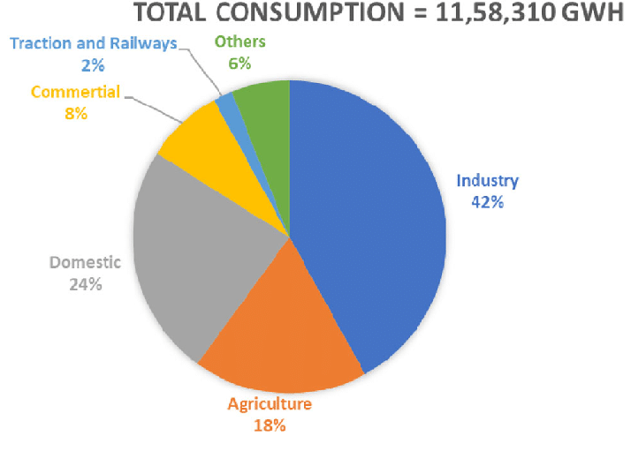

Here’s a high-level architecture for the project:

1. **Data Storage:** Store the collected data in a scalable and reliable data storage system, such as a data lake or a cloud-based storage solution like Amazon S3 or Google Cloud Storage.
2. **Data Ingestion:** Set up a data ingestion pipeline to collect data from various sources mentioned above. This could involve APIs, data scraping, or direct data feeds, depending on data availability and accessibility.
3. **Data Processing**: Preprocess the raw data to handle missing values, outliers, and inconsistencies. Perform data cleaning, normalization, and aggregation to prepare the data for analysis.
4. **Scalability and Maintenance**: Design the architecture to be scalable and adaptable to accommodate future changes in data volume, sources, or analysis requirements.

**CHAPTER 4**

**MODELING AND RESULT**

**Manage relationship**

The “sheet” file will be used the contains keys (states and column1) which can be use to relates the four data files together. The “long\_data” file is use to sum the states where high consumption take place.we using five type of attributes(longitude,latitude,region,states,usage).

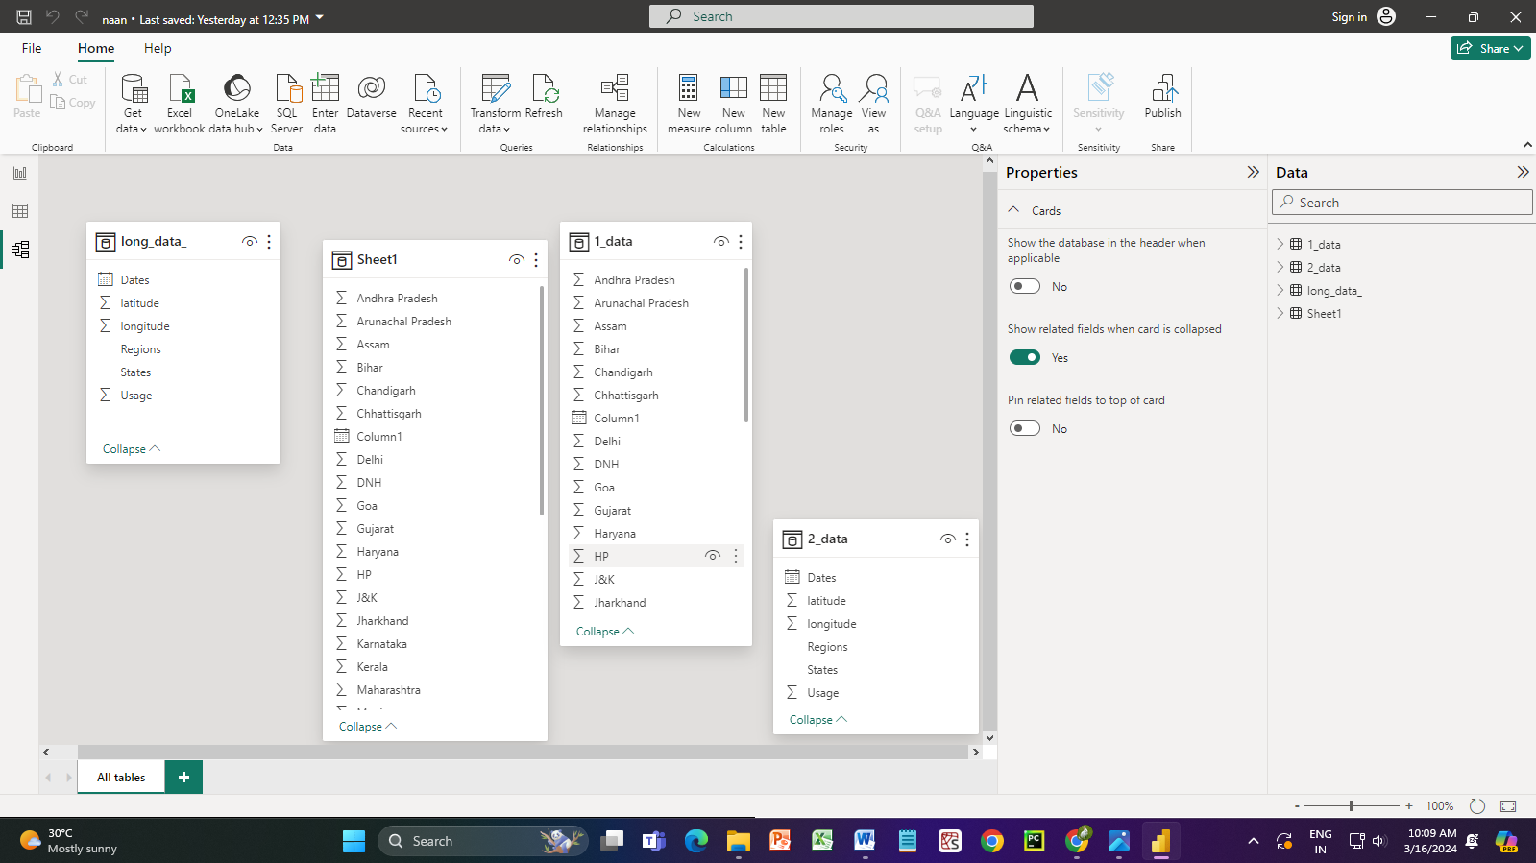

In this dataset has no relationship between any columns and rows .these dataset does not manage tables relation

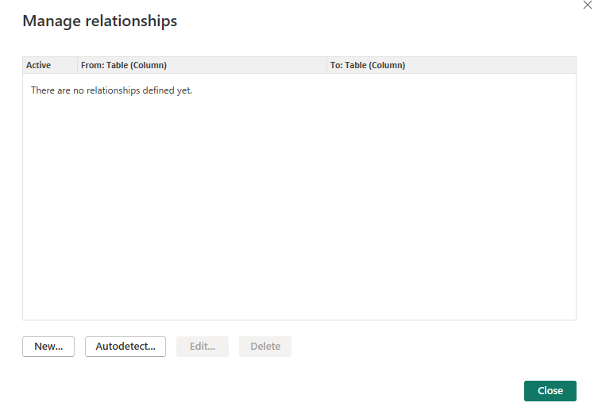

Some coding to calculate the electricity bills ,in condition to find the charges and which units consumed electricity.

Check units consumed is less than equal to the 100, If yes then the total electricity bill will be:

C:\Users\Admin\AppData\Local\Packages\Microsoft.Windows.Photos_8wekyb3d8bbwe\TempState\ShareServiceTempFolder\Screenshot 2024-03-16 120616.jpeg

Else if, check that units consumed is less than equal to the 200, if yes then total electricity bill will be:

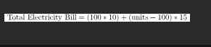

Else if, check that units consumed is less than equal to the 300, if yes then total electricity bill will be:

**Else if, check that units consumed greater than 300, if yes then total electricity bill will be:

**

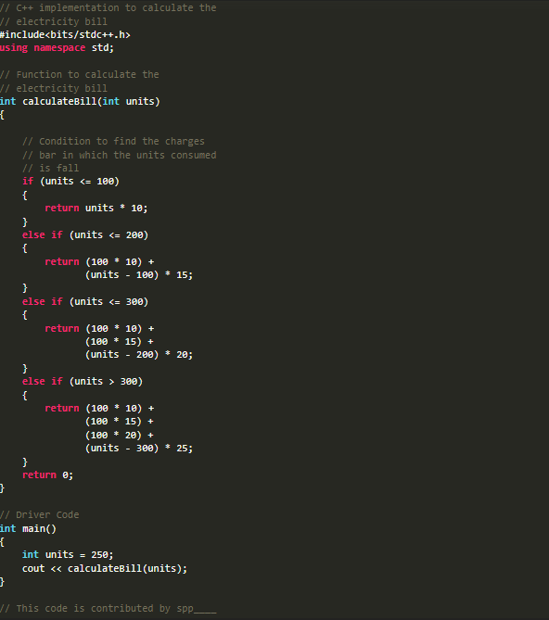

Output:



In this coding we calculate the bills for electricity consumption.these modeling and result of the electricity consumption in india. Obtaining commercial electricity consumption datasets can vary depending on your location and access to data sources

Modeling electricity consumption in India requires a multidisciplinary approach, incorporating domain knowledge, data analytics expertise, and an understanding of the socio-economic and environmental factors shaping energy demand in the country

**Dashboard**

We are apply sum of longitude of region given in the dataset

**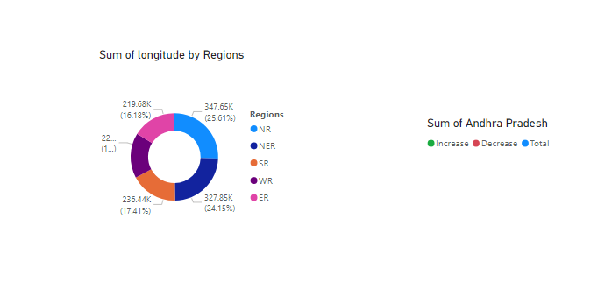**

Sum of usage of the electricity by states in India

**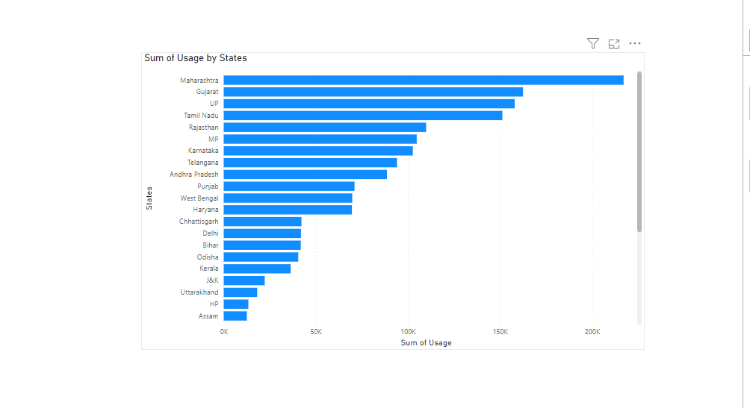**

In the bar chart ,x-axis is sum of usage and y-axis is states where located in india.consumption the electricity in state.

In tamilnadu SR region tamilnadu states in 151,271,50 sum of usage

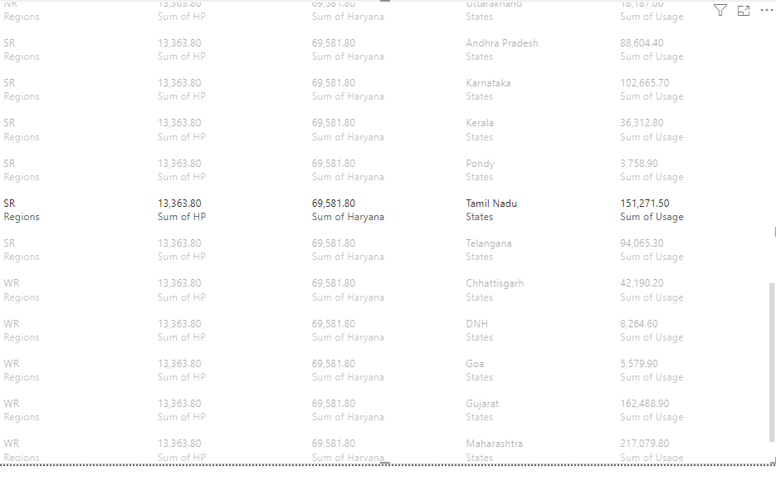

In this we use the application to create the dashboard in powerBI,using the dataset of electricity consumption

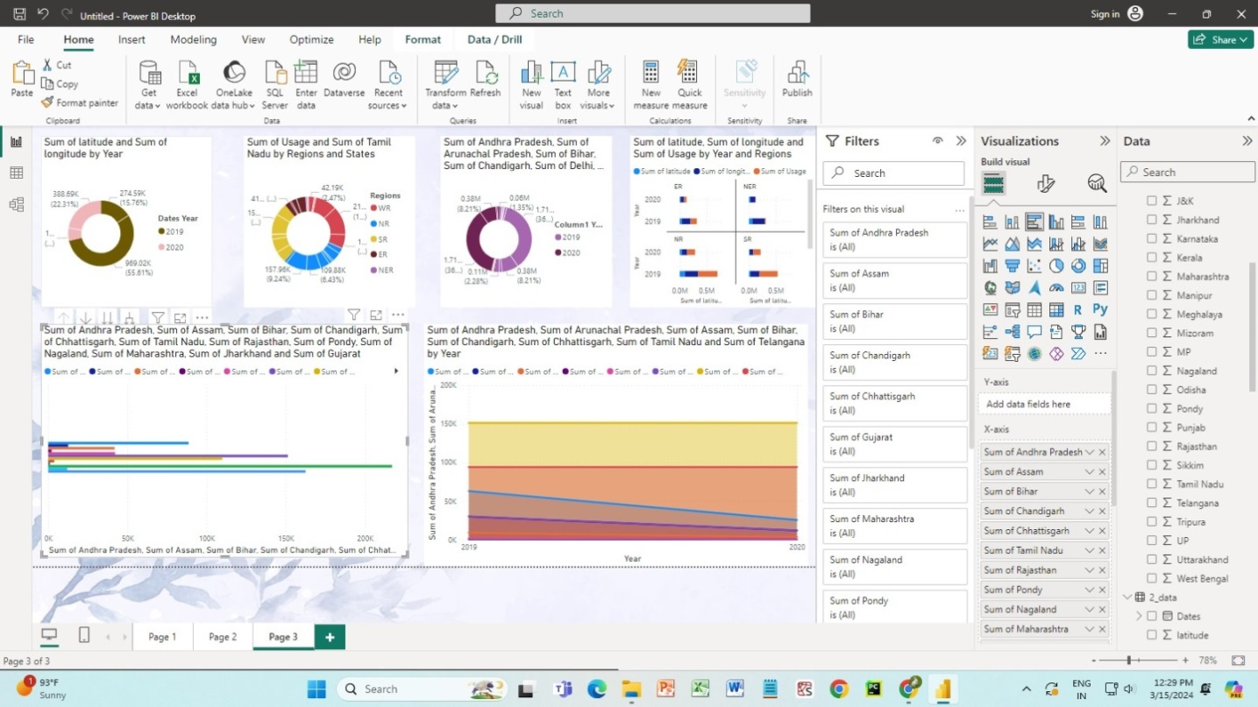

**CONCLUSION:**

The conclusion regarding commercial electricity consumption in Indian states would depend on various factors such as economic activity, industrialization, infrastructure development, and government policies. As businesses expand and new commercial establishments emerge, the demand for electricity increases. States with greater industrialization and commercial activity, such as Maharashtra, Gujarat, Tamil Nadu, and Karnataka, likely have higher consumption rates compared to less developed states. Government policies and initiatives play a crucial role in shaping commercial electricity consumption patterns, while there are general trends and considerations to be made regarding commercial electricity consumption in Indian states, the specific situation would vary from state to state based on individual socio-economic factors and policy environments.

**FUTURE SCOPE**

Here's a look at the future scope for analyzing commercial electricity consumption:

**Granular Data & AI:**

Deeper insights from high-resolution smart meter data. AI can analyze consumption patterns to identify inefficiencies and optimize energy use.

**Electrification Trends:**

The shift towards electric vehicles and heat pumps will impact commercial energy demand. Analysis can predict these impacts and inform grid planning.

**Sustainability & Renewables:**

Businesses will increasingly focus on reducing their carbon footprint. Analyzing consumption patterns can help identify opportunities for on-site renewables and energy efficiency measures.

**Dynamic Pricing & Demand Management:**

Time-of-day pricing will incentivize businesses to shift energy use to off-peak hours. Analysis can help optimize energy use based on these pricing structures.

**Overall:**

The electrical equipment market in India is poised for remarkable growth,with a projected CAGR of 11.68% between 2022 and 2027.This growth is expected to translate into a substantial increase of USD 52.97 billion in the market size.

**REFERENCE:**

<https://www.geeksforgeeks.org/program-to-calculate-electricity-bill/>

<https://chat.openai.com/c/9411f637-f23d-4769-9857-bac0f437f5c6>

<https://en.wikipedia.org/wiki/Electricity_sector_in_India>

**links:**